Create a Spring Web Project using Maven
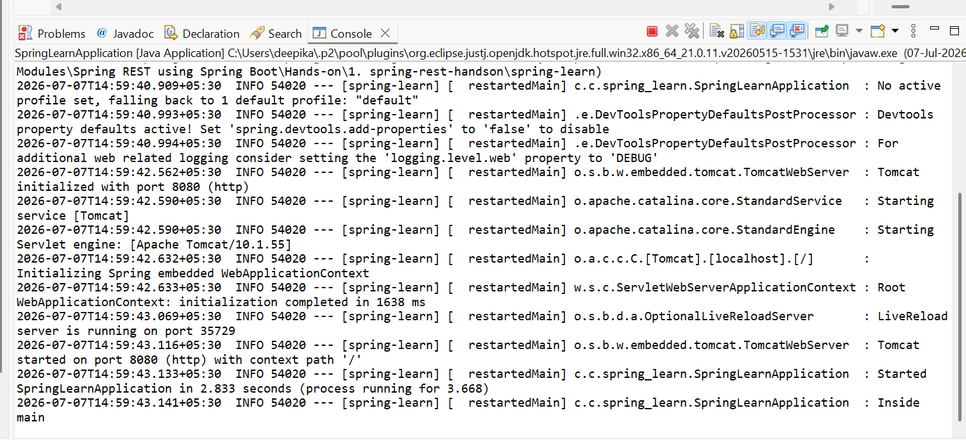
Spring Core – Load Country from Spring Configuration XML
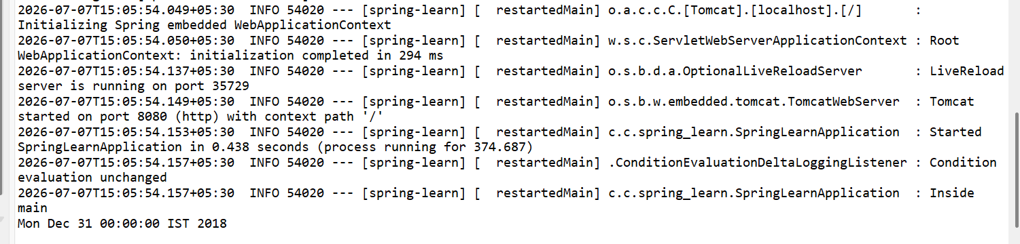
Hello World RESTful Web Service


REST - Country Web Service
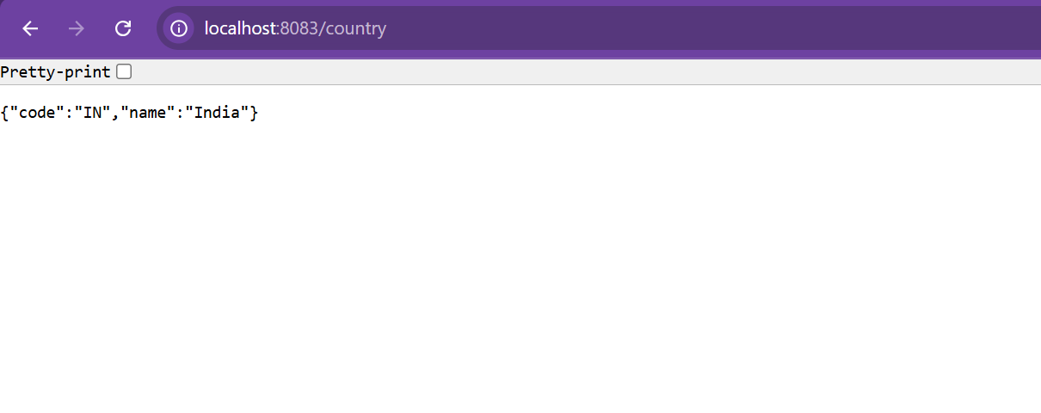
REST - Get country based on country code
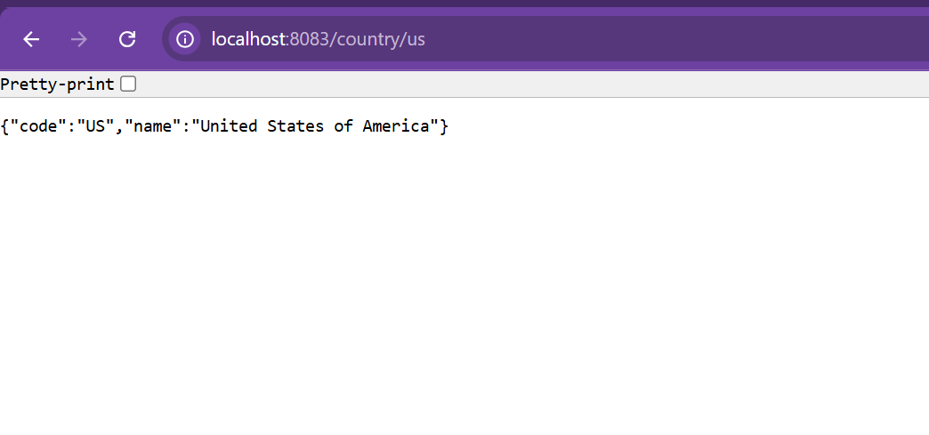
Create authentication service that returns JWT
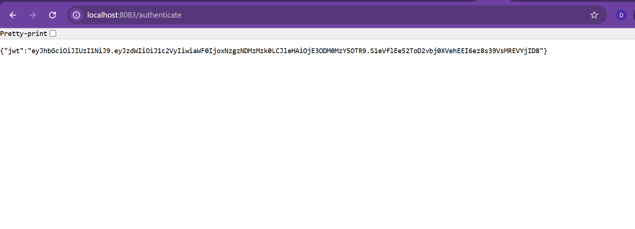

Additional hands-on
3. spring-rest-handson
